Competitive Balance in Formula 1 Racing: Do We Like Being Unfair?

Julienne H. Frasch
College of the Holy Cross, 2024
Advisor: Professor Victor Matheson
Department of Economics and Accounting Honors Thesis

Introduction and Literature Review
Formula 1 (also referred to as F1) is a fast-paced, high-stakes auto racing sport that, in the current day, consists of ten teams (constructors) with two drivers per team competing in 23 races in 20 different countries from March to November. At the end of each race, the top ten finishing drivers receive a certain number of points, depending on their finishing position, that goes towards the Drivers’ Championship, with the driver scoring the most points at the end of the season being crowned World Champion. The number of points that each driver receives also goes to their respective teams, which compete in the Constructors' Championship. The various constructors at the end of the season win prize money, with the top teams reaping significantly more rewards than the bottom constructors. This creates dominating teams, which consistently win, thereby earning higher returns, allowing them to sign on the best drivers in the world to race for their team, further extending their reign. Prior to 2021, winning teams had higher budgets to spend on R&D (research and development), which further fuels the cycle of dominance. These winning teams continue to have superior cars, as the top teams spend more money in the off-season to enhance the car.
Over the last 26 years, Formula 1 has changed drastically. Some of these changes include adjustments to the circuits on the schedule, regulations set by the FIA (Fédération Internationale de l'Automobile, the governing body of F1), and the number of constructors and drivers competing on the grid. The addition of one constructor on the grid results in two additional drivers fighting for wins, podiums, and points. The more drivers on the grid, the more racers each driver must compete with to get on the podium. While some teams have been an integral part of Formula 1 since its inception, such as Ferrari, many others have shifted over the years, enduring ownership changes, rebranding, or the entrance and exit of teams in the sport. All these changes can affect the competitive balance of F1.

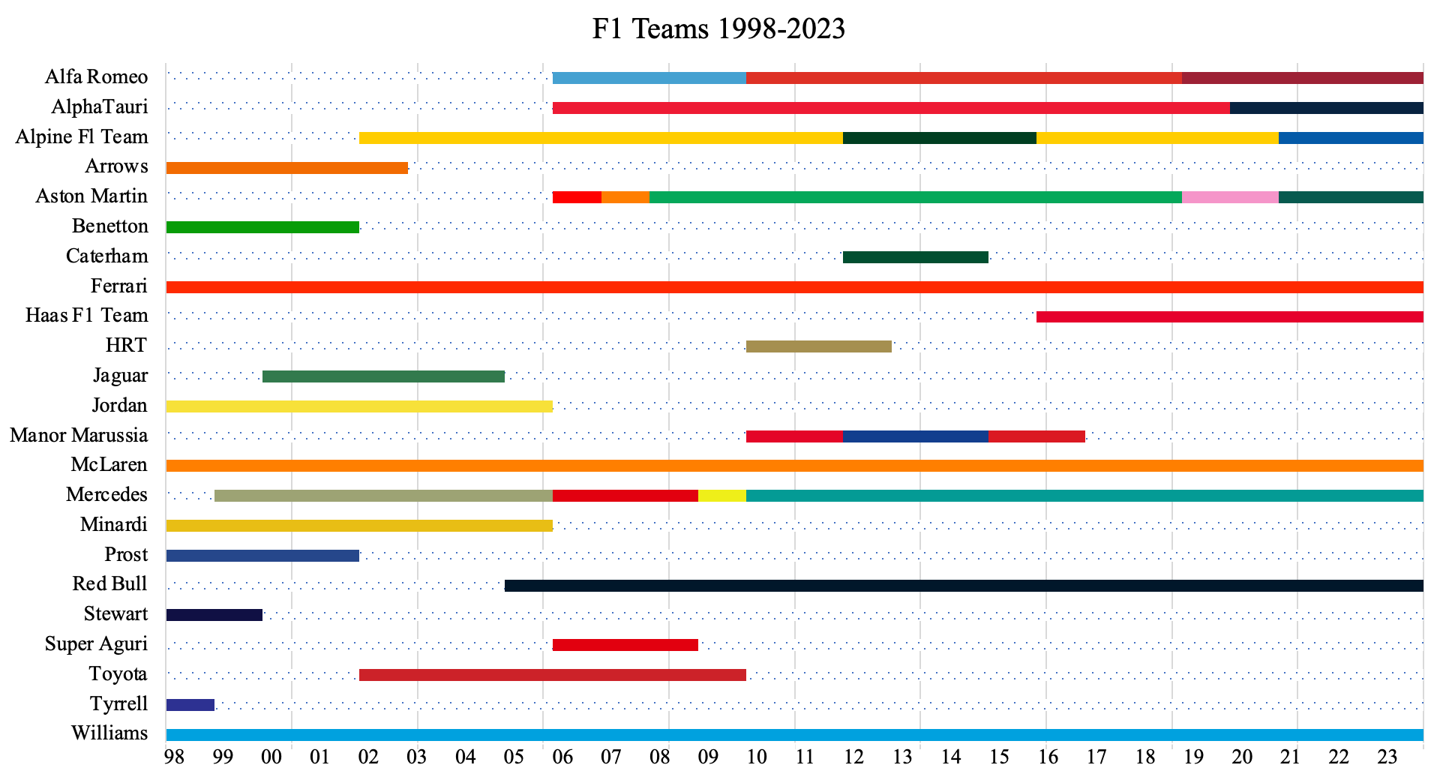
Figure 1: Timeline of constructors competing in Formula 1 from 1998-2023. The names listed on the left is the most recent name of the team/team’s name at the time of exit and the numbers on the bottom axis represent the year. Specific breakdowns of years are located in Table 4 of the appendix, and the teams that changed are outlined in Table 5 of the appendix.

Figure 1 above shows how the grid has changed over the years in terms of the constructors on the grid. Except for McLaren, Ferrari, and Williams, all other teams have either entered and exited Formula 1 or had to undergo rebranding or ownership changes. The constructors that have multi-colored timelines indicate such changes and the varying lengths of each color depict the length of time each constructor spent with a particular team name. These changes can have a significant impact on a team’s success, and the balance of the grid for the upcoming season. Every adjustment that a team makes has ripple effects on the rest of the grid, as the successes and failures of each team affect the standings in the championship, therefore affecting the rest of the grid.
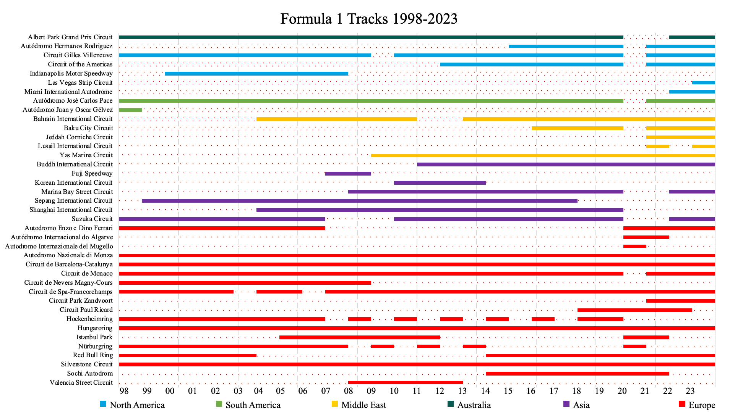
Figure 2: The timeline above illustrates the active Formula 1 tracks from 1998-2023. The names on the left axis represent the name of the track/circuit and the numbers on the bottom represent the year. The solid lines indicate years active (meaning a Grand Prix was held at that track for that year) and the dotted lines indicate inactive years.

As seen in Figure 2, Formula 1 has utilized a variety of circuits over the last 26 years, with a few classic tracks remaining constant, like Autodromo Nationale di Monza, Silverstone, and the Hungaroring, paired with the variety of circuits that get switched out every few years. All these changes can affect the competitiveness of the sport, and this paper aims to answer the following question: how has competitive balance in Formula 1 changed in the past 25 years and how has popularity in the sport changed? I hope to answer this question by measuring and mapping the competitive balance in Formula 1 racing from 1998-2023 and comparing it to levels of popularity in the sport over time.
To further understand what drives competitive balance, I looked at past publications to gain insight into what I could expect to find from this research. The first paper written on competitive balance came from Simon Rottenberg in 1956, in which he outlined the labor market of baseball players. After outlining the makeup of the baseball industry, Rottenberg found that various rules in the baseball industry, like territorial rights and uniform contracts, allow competition to remain balanced. He also found that baseball clubs generate revenue through attendance, which is often dictated by several factors, including the income of the territory, the population of the territory, price of attendance, quality and location of the ballpark, overall rank of the team, and quality of substitutes which can all affect the clubs’ ability to pay for players and fund their teams. Regarding competitive balance, Rottenberg argued that allowing players to move freely between teams would lead to a greater distribution of talent and skill, which would make the league more balanced and add to overall competition.
Additionally, a study published by Meehan et. al. (2007) measured the effects of a change in competitive balance on attendance at Major League Baseball games. Using an empirical model, they looked at the 2000, 2001, and 2002 MLB seasons. Using 7,189 observations, they ran a multiple regression with attendance as a proxy for demand as their dependent variable, and their independent variables of 30 control variables that control for a multitude of factors (day of the week, year, weather, the success of the team and their opponent, whether the game was played indoors, etc.). They measured competitive balance by comparing the difference in winning percentages of the home and visiting teams. They found that attendance is greatest on Saturdays, and greater on Fridays and Sundays compared to the rest of the week, and that day games attract more fans than night games. They also found that attendance decreased in the 2002 season, but this was paired with an increase in the unemployment rate. They also speculated that fans might have been hesitant to attend games following 9/11. In terms of weather, as the temperature outside increased, attendance also increased but as rain increased, attendance decreased. They found that if the game was being played in a new stadium, attendance went up, and fans preferred to be outside, as attendance decreased when compared to indoor stadiums. They also found that an increase in per capita income led to an increase in attendance. A higher quality home team brought more fans to the ballpark compared to an increased quality visiting team. Most importantly, they found that an increase in the difference in the winning percentages of the individual teams led to a decrease in attendance, indicating that a decrease in competitive balance led to a decrease in attendance, and therefore a decrease in demand. However, their data indicates that this only occurs when the home team has a better record than the visiting team. A change in competitive balance has no effect on attendance when the visiting team has a better record than the home team. Meehan, et. Al. (2007) concluded that attendance is maximized when the probability of the home team winning is between 0.6 and 0.7. This indicates that while fans like to watch their team win, they do not want their team to blow the visiting team out of the water. This is important, as it indicates that my research should focus on the constructors/drivers that are winning and the margins in which they are winning. The various factors discussed by Meehan et. al. (2007) provide a good indication of additional variables that could affect attendance other than competitive balance. Luckily for Formula 1 racing, all the action occurs on the weekend, so more fans are already being drawn to the racetrack compared to if races occurred during the week.
Looking more broadly at the overall demand for sports, Coates and Humphries (2007) explored the demand for professional sports using data that captures overall fan costs for attendance beyond ticket prices. They focus not just on the MLB but also the NBA and NFL. They use attendance as their dependent variable, and ticket prices and various concessions measurements as their independent variables. They found that ticket price is statistically significant in the NBA and MLB. Another approach for looking at the overall fan cost of attendance is the Fan Cost Index (FCI). Their FCI is particularly interesting. Their FCI runs on the assumption that consumers at sporting events are more likely to purchase a specific group of items which includes four average-priced tickets, four small sodas, two small beers, four hot dogs, two game programs, parking, and two adult-sized hats to incorporate the average spending of consumers at sporting events. The FCI is statistically significant in the NBA and nearly significant in the MLB. All the coefficients were negative, showing that as prices increase, attendance decreases. They found that the price elasticities are less than one and concluded that teams set prices on an inelastic demand curve in the NBA and MLB. They also found that the price elasticity for ticket prices is less than for the FCI, but that non-ticket components within the FCI have a higher price elasticity than the ticket component. The population of the surrounding metropolitan areas is significant for the NBA and MLB but not for the NFL, though average attendance at NFL games is closer to stadium capacity compared to the others. Their decision to focus on the FCI along with the average ticket price allowed for a broader and more comprehensive approach to demand.
Shifting gears to Formula 1, Judde, Booth, and Brooks (2013) found that Formula 1 teams act as point maximizers and that as rules and regulations change, competition becomes more balanced, with the main result being that the Drivers’ Championship is decided 6.9% later in the season. It extends the overall results of the season and creates more uncertainty for the whole season. They support this by analyzing the profits of F1 teams from 1950-2010 and found that profits stayed modest as they tried to maximize points. They found that new written regulations aimed at balancing competition have a greater effect on the season as opposed to individual races. When trying to measure competitive balance on the uncertainty of individual races, Judde, Booth, and Brooks used lead changes in the race as a measure but found the result to be “statistically and practically insignificant” and further explained that lead changes are more dependent on pit stops, aerodynamics, and track characteristics than on competitive bias.
Budzinski and Feddersen (2019) established that the Drivers' Championship for F1 is more balanced than the Constructors' Championship, and that the Formula 1 Drivers' Championship appears to be the most balanced championship across multiple sports when looking at 3 types of competitive balance: race-specific, within-season, and between-season. Utilizing Gini coefficients, they found that the overall trend is negative when looking at within-season competitive balance, indicating that competitive balance has improved over the years. An interesting point of their methodology was that they analyzed the competitive balance and closed gaps in the literature for “non-team sports.” I find this an interesting claim to make as Formula 1, along with being an individual driver sport, is also a team sport, with an entire Constructors’ Championship designed around the teams. The Constructors' Championship is on the other end of the scale, being one of the more unbalanced championships across all sports.
Two different hypotheses were tested by Mastromarco and Runkel (2009). They view F1 as a two-stage model: the first stage is the FIA deciding rule changes and the second stage is the actual season in which racing occurs. Starting with Stage 2, a team’s success was determined by developing an equation that would identify the probability of a team winning and what percent of prize money each team could get, considering a variety of factors such as driver salary and development costs. Moving to Stage 1, they model the revenue of the FIA and how that affects fan interest in the sport. When looking at whether competitive imbalance increases the likelihood of rule changes for the following season, they concluded that a lack of competitive balance is a motivator for rule changes. On the opposite end, they looked to see if more comprehensive rule changes lead to increased competitive balance and concluded that an increase in the number of rule changes at the beginning of the season improves competitive balance throughout the season.
Gasparetto et. al. (2022) found that an increase in ticket price leads to a decrease in demand for Formula 1 and found an inverted U-shape relationship between the uncertainty of outcome (UO) and attendance. Their results showed significantly that the most recent performance of a local driver has a positive effect on attendance but found no significant results that UO affects attendance. They include season and circuit fixed effects which help to form a more robust study. However, their dataset only contains data from 2015-2019 which limits the information provided. Furthermore, their regression did not include many control variables. They measure attendance by the number of tickets sold, which I believe creates some bias, as some circuits have a higher capacity and therefore can sell more tickets. If tickets were measured in terms of capacity, they could have achieved more accurate results. They also described in detail the difficulty of acquiring data from Formula 1, which is a difficulty that I also experienced throughout the process of this project and discussed in the Data section.

Methodology
The goal of this paper is to expand on the existing literature by including competitive balance measurements that are not commonly used in the field and connecting competitive balance with public interest in this specific sport. This is most effectively done using both within-season and between-season approaches. Within-season competitive balance measures the balance of competition throughout one season, while between-season competitive balance measures the fairness of competition throughout multiple seasons. The methodology behind this research will be an empirical paper mapping the competitive balance of Formula 1 from 1998-2023 and comparing these measurements on Google Trends data to use as a proxy for popularity/interest in the sport. The existing literature is expanded using four measures of competitive balance: Gini coefficients, the Herfindahl-Hirschman Index (HHI), Mean Average Distance (MAD), and correlation coefficients. The two most common methods used in prior publications are the Gini coefficient and the Herfindahl-Hirschman-Index (HHI). The Gini coefficient is the go-to method for measuring inequality, specifically income inequality, but is also used across many topics, including sports literature. The HHI is commonly used as it is an effective measure of market share, which is easily transferable to sports and can be utilized to measure shares of wins, points, etc. As Gini coefficients and HHI values are measured for each individual season, they will be used to measure within-season competitive balance and then expanded upon to view how the within-season balance has changed over the last 25 years. The MAD and correlation coefficients are not commonly used to measure competitive balance, so a goal of this paper is to explore the inclusion of these measures and compare them to the commonly used measures, hoping to see if these other measures tell a different story. The MAD and correlation coefficients will be used to measure between-season competitive balance. When looking at the Drivers’ and Constructors’ Championships, I focus on both when calculating the Gini coefficients and HHI. For the MAD and correlation coefficients, only the Constructors’ Championship is analyzed. This is done to eliminate complications of measuring the results of drivers over time, as focusing on the constructors in Formula 1 is more consistent than focusing on drivers. Many drivers rapidly enter and exit Formula 1, and drivers may change teams over the course of their careers. This factor makes it more difficult to measure competitive balance when focusing on the Drivers’ Championship. Focusing on just the Constructors’ Championship allows me to get a better and more consistent understanding of competitive balance in Formula 1.
The Gini coefficient will be measured between the values 0 and 1 and these coefficients were calculated using the standard equation:
$$G= \frac{A}{B}$$
where G represents the Gini coefficient, A represents the area between the line of perfect equality and the Lorenz curve, and B represents the total area under the perfect equality line.
The standard equation to calculate the HHI for any given year utilizes a sum of squares approach:
$$HHI=s1^{2}+s2^{2}+…+sn^{2}$$
where s1, s2, etc. represent market shares, which in my case will represent shares of wins for each driver. I plan to calculate the HHI for both the drivers and the constructors (n represents the number of drivers or constructors on the grid for that year). With values ranging between 0 and 1, the HHI will show me the share of wins by each team for each season, with an HHI closer to 1 indicating that one team and/or driver won a large percentage of the races, indicating a lower competitive balance. An HHI closer to 0 would indicate that race wins are spread across multiple teams and/or drivers, suggesting that competition is more balanced.
The Mean Average Distance will be calculated using the following:
MAD_{constructor} = ∑ (α_{it} - α_{it-1}) / n_{constructor}
where α_{it} is the points earned for each constructor of that year, α_{it-1} is the points earned of the previous year, and n_{constructor} is the number of constructors on the grid for that year’s season. The goal of this calculation is to pinpoint changes in points across the years. If the MAD = 0, there was no change in the points a team earned from one year to the next, indicating that there is no movement on the grid, implying the grid is competitively unbalanced. The MAD will be calculated using an absolute value, as the goal is to see if there is an overall change in the points as opposed to a direction. Some teams will have a good season and increase their points from the previous year, leading to a positive MAD, while other teams will perform worse and earn fewer points, which will lead to a negative MAD. This could cause the results to skew, so taking the absolute value of finish position changes will prevent this. When calculating the MAD, only data on the constructors was used instead of the drivers, as there is little change in the constructors from year to year. There might be a team name change, but there is not much change in terms of new teams entering or leaving Formula 1. This provides more consistent data to work with. If the research focused on just the drivers, it would have been very difficult to calculate over time, as every year various drivers leave and enter Formula 1, along with drivers switching teams. Omitting the drivers from this measurement and only including the Constructors’ data allows for greater data integrity.
Lastly, correlations using the points earned by each constructor of any given year and the points earned in the previous year were calculated to see if points earned in one-year influence points for the next year. These values were calculated by compiling data on points earned by each team for a given year and for the previous year and utilizing the correlation function in Excel to calculate the correlation coefficient for each year.
After establishing how competitive balance has changed over time in Formula 1, Google Trends data was analyzed to establish how interest in Formula 1 has changed over time, with the goal being the establishment of a connection between competitive balance and interest in the sport. Two different perspectives were analyzed: Internet searches of F1 vs NASCAR in the United States to see if there was growing popularity in Formula 1 or motorsports in general, and Internet searches of F1 in the United States compared to searches of F1 worldwide. The goal of looking at this data is to see if changes in trends align with changes in competitive balance.

Data
Data from various countries was collected and compared, looking at the United Kingdom, Hungary, Italy, the United States, and Belgium. Specifically, the following circuits were analyzed: Silverstone (United Kingdom), Hungaroring (Hungary), Autodromo Nazionale di Monza (Italy), Circuit of the Americas (USA), Indianapolis Motor Speedway (USA), and Circuit de Spa-Francorchamps (Belgium). These were included in this research because all these countries have hosted at least one Grand Prix yearly, over many years. The nature of Formula 1 is to change the schedule yearly: making sure to include new countries to expand the sport, while also keeping some iconic tracks in the schedule that have traditionally been included for many years. Keeping this in mind, I felt it would be best to focus on those classic tracks in my research as they have more consistent data available than newer tracks or tracks that occur on the schedule only every few years. The United States was included in the dataset due to the recent spike in interest in Formula 1 in the United States over the last few years, paired with a consistent race history over the last two decades. The scope of this research looks at data from 1998 through the 2023 season, as 1998 marks the beginning of the modern Formula 1 racing era and accounts for the introduction of the Internet around 2000, encompassing everything in a quarter-century of data.
The data source for this research comes from RacingStatistics.com. The website contains information from 1950-present on every driver and constructor for every race, including race results, points earned, race times, qualifying times, and starting grid position. It contains the same information that is provided on Formula 1’s website, however, it is formatted in a way that is easier for data collection. The dataset for this research was custom created, as there were no sources that allowed the data to be exported in a meaningful way for productive analysis. Data from this website was used to calculate all measures of competitive balance that were discussed earlier in the methodology section of the paper. The information regarding points is also important, as the points each driver earns directly affect their, and their constructor’s, standing in the championship.
All the data regarding popularity that has been collected has come from Google Trends. There are some concerns with the Google Trends data, as it is reported as an index instead of raw data. Google Trends reports its data by taking the point of highest popularity with regard to Google searches and marks that as 100. It subsequently compares every data point relative to that 100. While Google Trends data was not ideal for measuring popularity, I faced many challenges when it came to collecting data regarding interest and popularity, mainly because none of the data is available. The timeframe for the Google Trends data will be from Jan 2004 - Nov 2023, as the data is only available starting in 2004. A benefit of Google Trends is that it measures internet searches by month, so I am able to see how public interest has changed over multiple years, as well as within a specific year, thereby allowing the interest fluctuations during the season to be interpreted. Data for this research was very scarce and there is little to no data available beyond the Championship data found on Formula 1’s website. Ideally, I would have liked to include data regarding ticket sales, weekend attendance, or television viewership as a measure of popularity, but this data is rarely disclosed and is either very scarce or not available. Additionally, I reached out to Formula 1 and Thadeu Gasparetto to inquire about data for this paper and have yet to hear a response.

Findings & Discussion
The results of competitive balance in Formula 1 are mixed. Before delving into the results, I was curious to see if certain dips or peaks lined up with changes in the winners of the Constructors' Championship. Figure 3 depicts the winning teams of the Constructor’s Championship from 1998-2023.

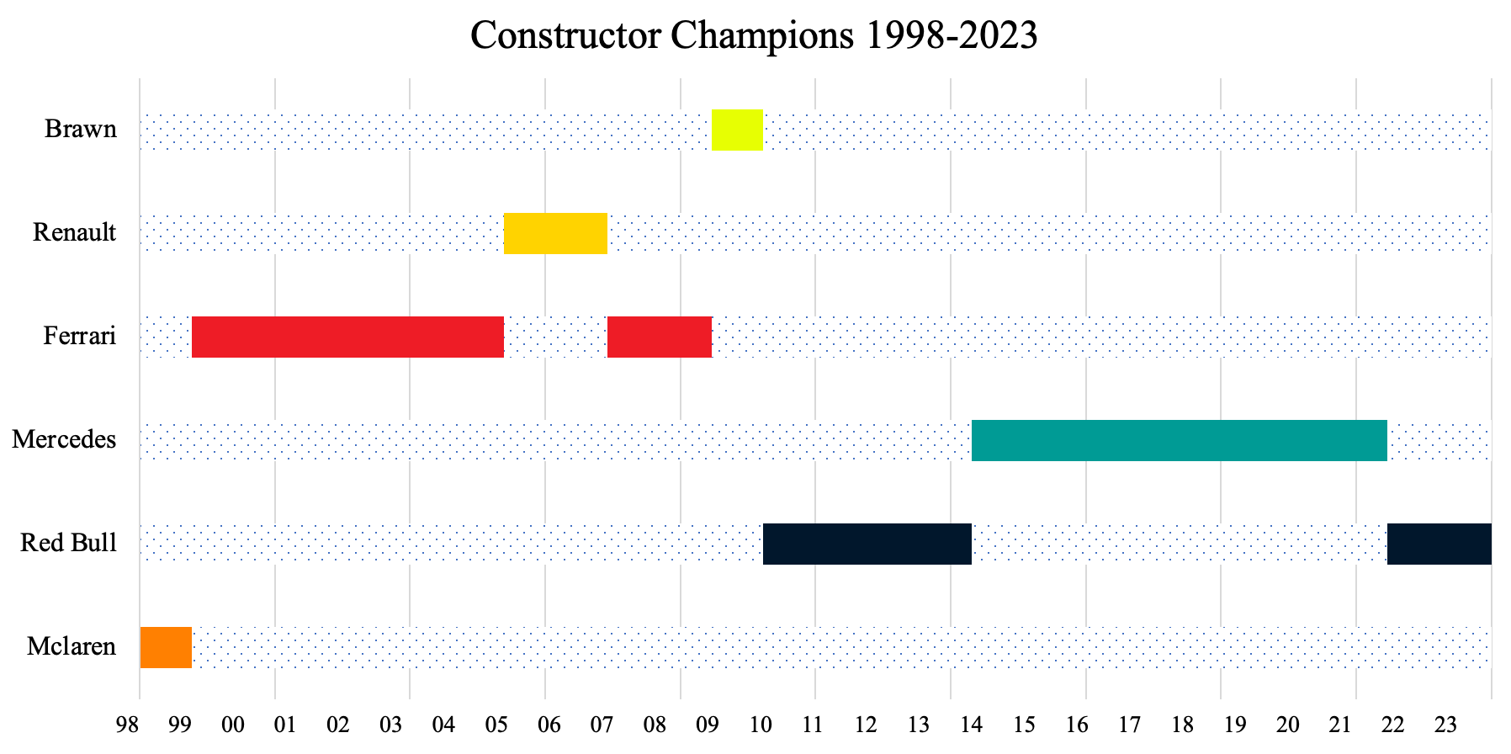
Figure 3: The timeline above outlines the different Constructors’ Champions from 1998-2023. Names on the vertical axis represent the name of the Constructor that won, and the horizontal axis depicts years. Team names are written as the name of the constructor at the time of the Championship. Specific years are outlined in Table 7 of the appendix.

In the last fourteen years, the Constructors' Championship has been dominated by two teams: Red Bull and Mercedes. Before that, Ferrari won the Constructors’ Championship in eight of the prior twelve years. Some important years to make note of are 2005, 2009, 2014, and 2021. All these years represent disruptions for the dominating team of that year. 2005 marked the start of a two-season break in Ferrari’s dominance. 2009 represents the underdog year of Brawn, a low-level team in 2008 that won the Constructors’ Championship and the Drivers’ Championship with Jensen Button in 2009. 2014 marked the beginning of Mercedes’s eight-season streak of winning the Constructors’ Championship and while Red Bull did not win the Constructors’ Championship until 2022, their reign began in 2021, when Max Verstappen won his first world title by winning the Drivers’ Championship.
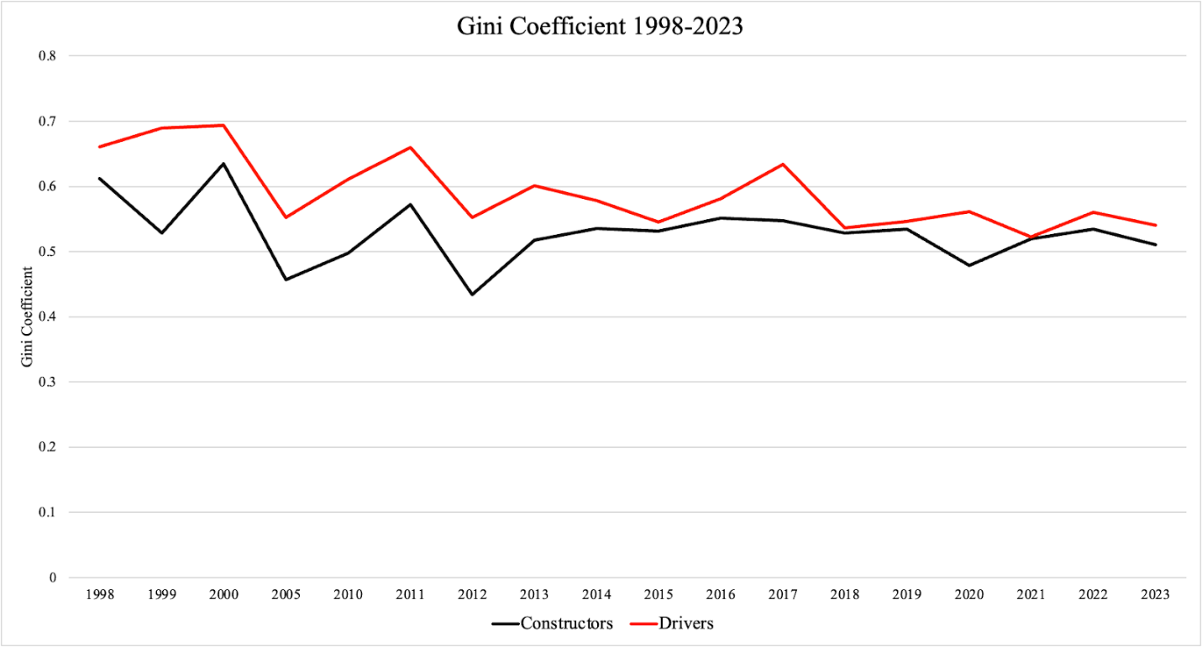
Figure 4: Correlation coefficients for Constructors’ and Drivers’ Championships for 1998-2023
Moving to measures of competitive balance, the Gini coefficients from 1998-2023 show a different story from the rest, as it shows that competition has become increasingly more balanced over time. As seen in Figure 4 above, there was a downward trend in the Gini coefficient from 1998-2012 for both the Drivers’ and Constructors’ Championships. From there, the lines begin to deviate. Following 2012, the Gini coefficient for the Constructors’ Championship increased and then held steady until 2020, when it decreased slightly. Overall, the Gini coefficient fluctuates between 0.43 and 0.57, with only 1998 and 2000 going above 0.57. For the Drivers’ Championship, the Gini coefficient follows suit in the slight increase in 2013, but then deviates from the Constructor’s Championship, as the coefficient for the Drivers’ Championship fluctuates during the years that the coefficient for the Constructor’s Championship holds steady. For the Driver’s Championship, the coefficients fluctuate between 0.54 and 0.69, with the majority of the movement occurring between 0.54 and 0.63. This indicates that the Driver’s Championship has experienced more inequality over the years compared to the Constructors’ Championship, as the higher the Gini coefficient, the higher the inequality and the lower the competitive balance. This deviates from findings in the literature, which indicated that the Drivers’ Championship was more balanced than the Constructors’ Championship.
A Gini of 0.43 is on the more equal half of the scale, indicating that seasons where the Gini was near 0.43 were seasons where competition was more balanced. A Gini of 0.57 indicates medium to high inequality, meaning a medium to high level of imbalance in Formula 1. The sudden evening out from 2013 to 2020 Constructors’ Championships lines up generally with the Mercedes era of dominance, where Mercedes won the Constructors’ Championship every season from 2014-2021. The majority of the results lie between the 0.5 and 0.6 mark, indicating a high level of imbalance. Much of the movement from 1998 to 2013 can be explained by the variations in winners of the Constructors’ Championship, as illustrated in Figure 3. From the Gini coefficients, competition in F1 from 1998-2023 has become more balanced over time.

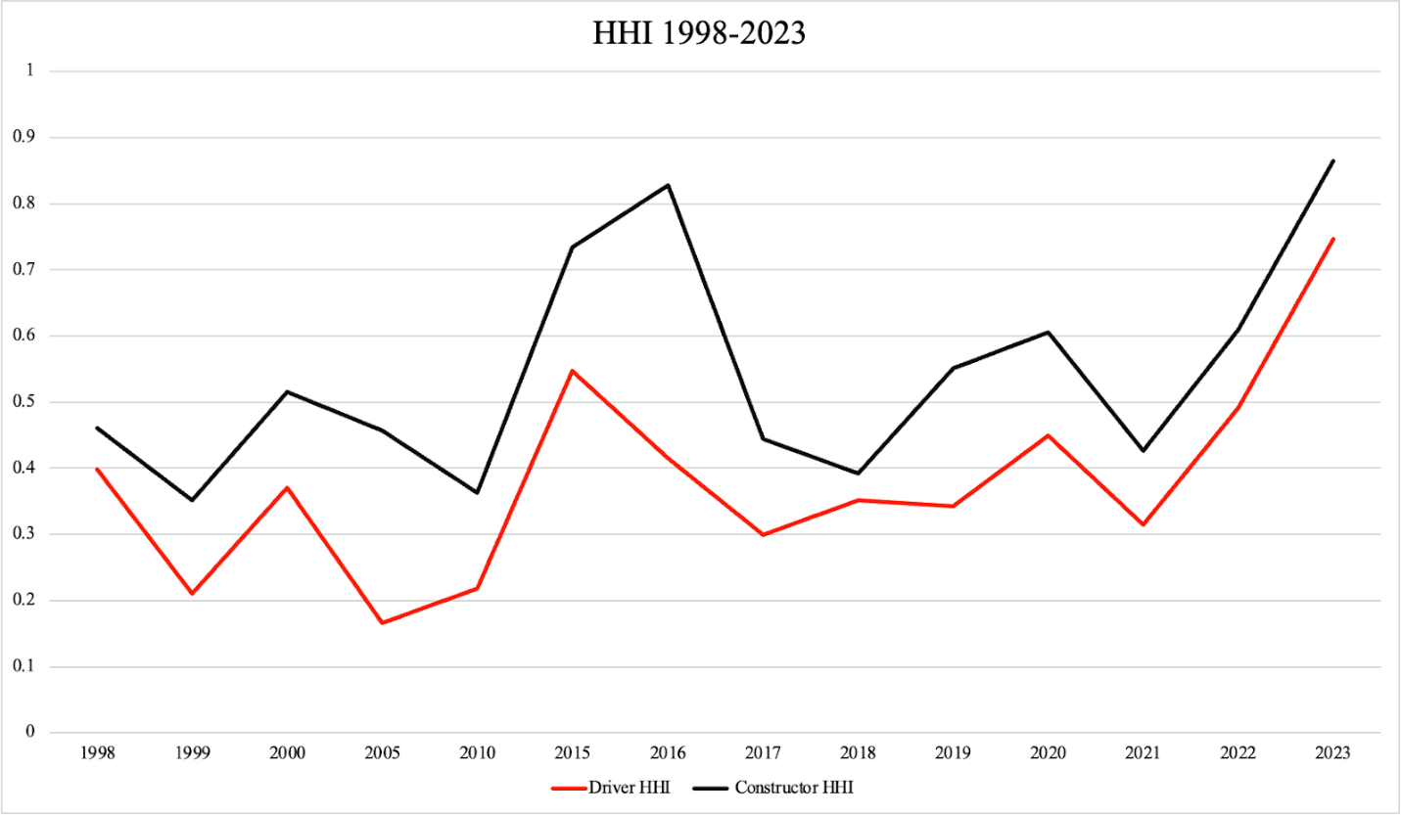
Figure 5: Herfindahl-Hirschman Index (HHI) for Constructors’ and Drivers’ Championships 1998-2023
Shifting to HHI, this method provides a different result as compared to the Gini coefficients, as it shows that competition becomes more unbalanced over time. There is an overall upward trend of the HHI from 1998 to 2023 with both lines, indicating that competition has become more unbalanced in both the Drivers’ Championship and the Constructors’ Championship over time. Since HHI is calculated by year and does not involve a t-1 variable, the Drivers’ Championship was included, as driver movements across years did not need to be accounted for. As the HHI increases, it indicates an increase in “market share” or in this case share of winnings, which leads to a decrease in competition, and a more unbalanced grid. HHI indicates that Formula 1 is becoming increasingly unfair over time. The Drivers’ Championship is more balanced than the Constructors’ Championship. The HHI is particularly volatile, with many increases and decreases over time. This is due to the nature of Formula 1 and motorsports in general. There is a constant uncertainty of outcome in motorsports, as any number of unpredictable things can occur that can affect the outcome of the race and season. Cars break down, drivers crash, and teams can have one or more off years. All these variables affect the outcomes of races, which affect the HHI.
The 1999 season saw a dip in both Driver and Constructor HHI, as six drivers from four constructors won races in the 1999 season, with the top driver, Mika Heikkinen, only winning 31% of the races and the top constructor, McLaren, only winning 44% of races. This contrasts with the 1998 and 2000 seasons. In 1998, total race wins were taken up by four drivers from three different constructors, however, the top driver and constructor, also Mika Heikkinen and McLaren, won 50% and 56% of races, respectively. The 2000 season saw only three drivers from two constructors winning races, with Michael Schumacher and Ferrari winning 53% and 59% of races, respectively. These years demonstrate how the balance of the sport can fluctuate from year to year.
The major spike in Constructor HHI in 2016 was likely due to Mercedes winning 90% of the races of the season, with the other 10% being won by Red Bull. Nine of eleven teams on the grid failed to win a race in the 2016 season, resulting in the largest spike in HHI. The spike in the Driver HHI in 2015 is due to only three drivers winning races in 2015, with Nico Rosberg winning 62.5% of the races that season. Compared to five drivers winning races in 2010, with three different drivers winning covering 73% of wins (26%, 26%, and 21%), it is clear how 2015 would prove to be an unbalanced year competitively. The HHI is contradictory to the Gini coefficients, as the HHI suggests that competition has become more unbalanced over time.

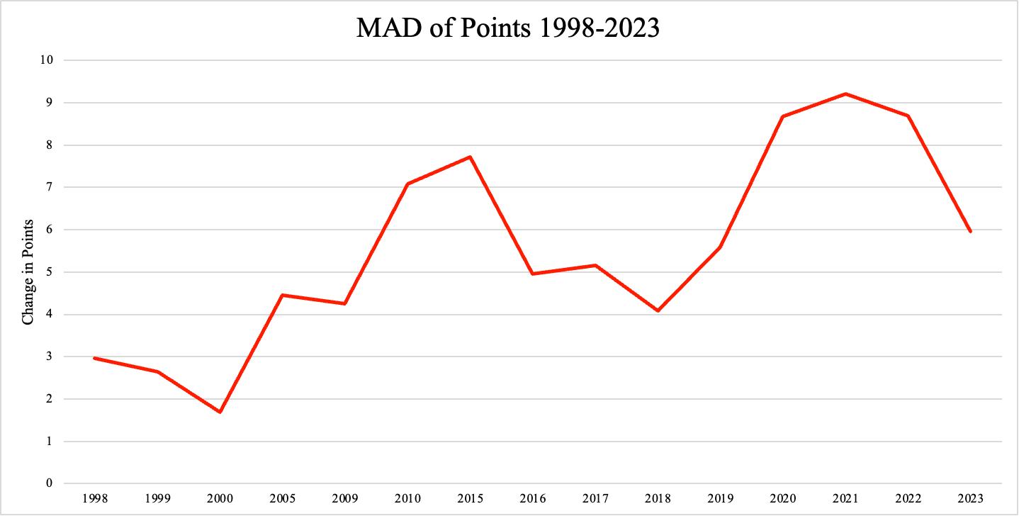
Figure 6: Mean Average Distance (MAD) for Constructors’ Championship 1998-2023

When looking at the mean average distance, as seen in Figure 6, it initially appears that competition has become more balanced over time, as the average change in points increases, indicating that teams are earning different amounts of points year over year, but that does not tell the full story. The graph is approached in two phases: 1998-2009 and 2010-2023 due to a major rule change in 2010, where the points system was updated, and the overall number of points awarded increased substantially. Instead of the race winner and constructor being awarded 10 points, they were now awarded 25. From 1998 to 2009, there was an increase in the MAD, from just under three points difference to a little more than four points for each race. This suggests that teams are finishing within 1-2 positions that they had at that race the previous year. Looking at 2010 to the present, the is very little change in the overall trend when it comes to the change in points over the years, with the average in 2010 being seven points and the change in 2023 being six points. From 2010 to 2018, there was an overall decrease in the MAD, from seven points to four points, indicating a decrease in competitive balance, suggesting that teams were finishing around two positions above or below where they had the year previous for that race. From 2018 to 2021, the MAD increased again from four points to just over nine points, before decreasing again from 2021-2023 from nine points to six. While it may appear that competition became more balanced over time, competition remained at about the same level of unbalanced as it was in 1998.

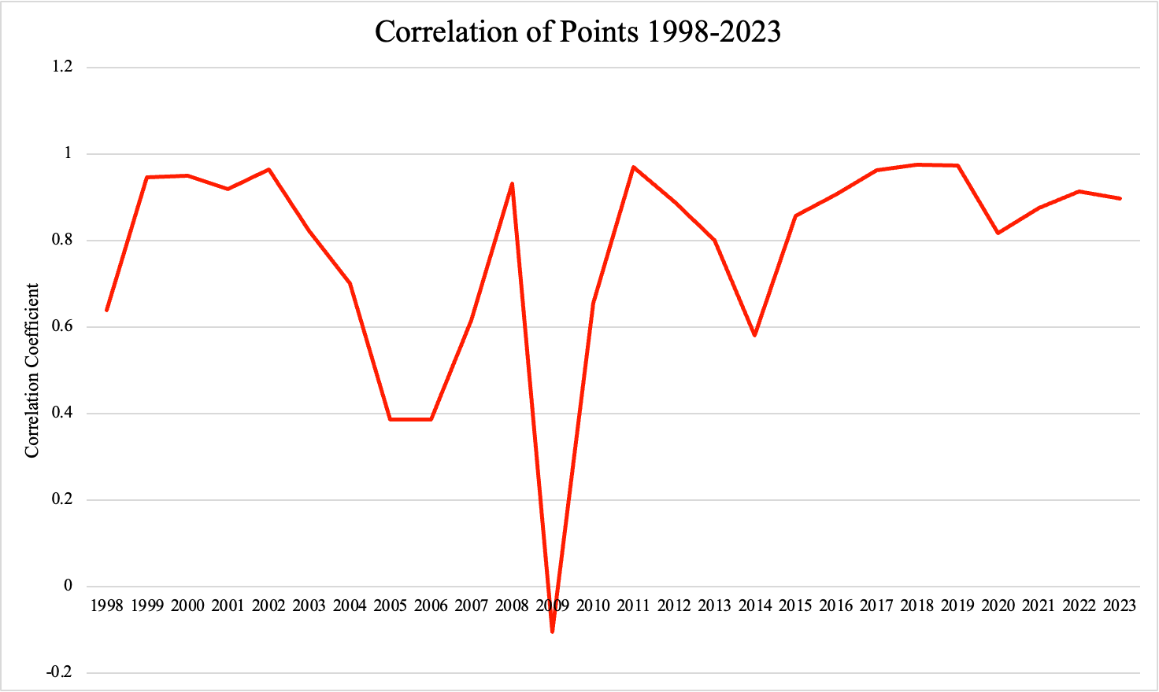
Figure 7: Correlation coefficients for points for any given year and the previous years for 1998-2023.

Lastly, looking at correlations of points, the results show some volatility over time, but overall show strong correlations between the points of a given year and points of the previous year, indicating teams are earning roughly the same number of points from year to year, suggesting that competitive balance follows the same trend as the previously mentioned measurements, in that Formula 1 is unbalanced. Most of the correlation coefficients ranged between 0.6 and 1, indicating that the previous year’s points can be highly predictive of the current year’s points.
As Figure 7 indicates, 2009 shows up as a clear year of interest, as the correlation coefficient drastically decreases and goes negative from 2008 to 2009, and then returning to about the same level in 2010. This is likely due to the constructor Brawn winning the Championship. In 2008, Brawn (Honda at that time) finished P9 in the Constructors’ Championship standings out of eleven teams. The following year, the team (now racing as the constructor Brawn) won both the Drivers’ and Constructors’ Championships and the usual top constructors like Ferrari and McLaren (finishing P1 and P2 in 2008, respectively) did not perform as well in the 2009 season (McLaren finishing P3 and Ferrari finishing P4). This would greatly affect the correlation coefficient for 2009, as the standings from 2008 were not indicative of the 2009 season. The coefficient returned to its high level in 2010 because the top four finishing teams in 2009 were the same top four finishing teams in 2010 (with Brawn becoming Mercedes in 2010). Overall, the high correlation coefficients suggest that competition is unbalanced, with variations occurring when there is a transition of dominating teams. The dip in 2014 is consistent with the transition in Constructors’ Champion, as the streak of Red Bull championships ended, and the streak of Mercedes championships began. The major dips in correlation coefficients occur when there is a change in the Constructor Championship. This offers insight that the other measures don’t capture. The other measures show similar results, in that competition in Formula 1 is unbalanced, however, they do not depict the same level of variation as the correlation coefficients that demonstrate the imbalance in Formula 1 is due to long stretches of dominance by various teams and the moments of increased balance in the sport is consistent with transitions between these dominating teams.

Figure 8: Internet searches for F1 vs. Internet searches for NASCAR in the United States from 2004-2023

Shifting to the Google Trends data, I found that interest in Formula 1 has grown over time. At first glance, NASCAR dominates over F1 when it comes to internet searches until 2021, when internet searches for F1 start drastically increasing, enough so that it overtakes NASCAR in interest. Internet searches for F1 start to pick up in 2019 and then increase significantly in 2021. The slow increase in 2019 could be explained by the release of the Netflix series Drive to Survive which became popular in the United States. The large jump in 2021 is consistent with the results from Figures 4-7, as the various measures of competitive balance all experience some kind of movement. 2021 also marked the first World Championship victory for driver Max Verstappen, a championship that was decided in the last lap of the last race of the season in December 2021. This large jump in 2021 also lines up with the sharp increase in HHI and decrease in MAD starting in 2021, suggesting that as Max Verstappen started to establish himself as a Championship winner with Red Bull, this may have attracted more people to the sport, as shown in the sharp increase in Google searches.
Figure 9: Ratio of F1 and NASCAR internet searches in the United States paired with number of F1 races hosted in the US from 2004-2023

To compare further, Google Trend values for F1 and NASCAR in the United States were divided to investigate how the ratio of internet searches has changed over time. The blue line represents the ratio of F1 Internet to NASCAR searches in the United States and the red line shows the number of F1 races hosted in the US for each year, as I was interested in seeing if interest in F1 increased or decreased depending on the recent increase in the number of races held in the United States. It is important to understand in Figure 9 that once the blue line reaches beyond 1 on the F1/NASCAR axis, this indicates that there are more Internet searches in the United States for F1 than there are for NASCAR. This indicates an increase in interest in Formula 1 in the United States. While there are a couple of small peaks that go beyond that threshold before 2021, there is a significant upward trend in 2021, so much so that at its peak, people were googling F1 four times as much as they were NASCAR.
Figure 10: Ratio of Internet searches for F1 in US and Worldwide paired with number of F1 races hosted in the US from 2004-2023

Lastly, Internet searches for F1 in the US to Internet searches for F1 worldwide were compared. The blue line represents the ratio of US searches to worldwide searches and the orange line shows the number of F1 races in the US for each year. There is an upward trend in Google search in the US compared to worldwide, with major increases occurring in 2021. The significant increase in the ratio starting in 2021 is largely driven by the increase in US interest in F1, driving the upward trend in the data.

Conclusion and Final Thoughts
In the fast-paced sport of Formula 1 racing, it is easy for top teams to maintain their dominance at the top while the rest of the teams battle it out at the bottom. This creates a very unbalanced grid, making it difficult for new or lower-level teams to advance and break into the top, elite level of Formula 1. As a whole, both the Drivers’ and Constructors’ Championship in Formula 1 racing are unbalanced and have become increasingly unbalanced over time, taking away competitiveness from the sport. This can create long-term challenges, as lower-performing teams may be forced to exit the sport if they are unable to break into the upper standings of the championship, and therefore unable to earn the increased prize money. Additionally, the drivers racing for these teams are more likely to switch to other teams rather than renew their contracts, further hindering the team’s ability to perform, as highly skilled drivers prefer racing for the best-performing constructors. The unbalanced competition also increases the barrier of entry for new teams into the sport, as the lower chances of revenue may not outweigh the costs of funding a team.
Given the challenges with using driver data and focusing more on constructor data, this research would be improved by expanding the data over a longer term to gather more observations. Additionally, this project could also be improved by looking at the changes in competitive balance using data that omits the top 3 drivers and constructors, as the mid-field and bottom are where most of the action occurs, and it could be interesting to see if the results vary when focusing on those areas without including the top teams. The data could also be improved by including other measures of popularity, such as ticket sales and weekend attendance, so the popularity results are less dependent on Google Trends data.

References
Budzinski, Oliver, and Arne Feddersen. 2019. "Measuring competitive balance in Formula One Racing." Ilmenau Economics Discussion Papers 25 (121), Technische Universität Ilmenau, Institut für Volkswirtschaftslehre, Ilmenau
Coates, Dennis, and Brad R. Humphreys. 2007. "Ticket prices, concessions and attendance at professional sporting events." International Journal of Sport Finance 2 (3): 161-170.
Formula 1 Statistics. http://www.racing-statistics.com/en.
Gasparetto, Thadeu, Marina Orlova, and Anton Vernikovskiv. 2022. "Same, same but different: analyzing uncertainty of outcome in Formula 1 races." Managing Sport and Leisure, DOI: 10.1080/23750472.2022.2085619
Judde, Chris, Ross Booth, and Robert Brooks. 2013. "Second Place Is The First of the Losers: An Analysis of Competitive Balance in Formula One." Journal of Sports Economics 14 (4): 411-439, DOI: 10.1177/1527002513496009.
Leeds, Michael A., Peter von Allmen, and Victor A. Matheson. 2022. "Competitive Balance." In The Economics of Sports, 127-156. New York: Taylor & Francis Group.
Mastromarco, Camilla, and Marco Runkel. 2009. "Rule changes and competitive balance in Formula 1 motor racing." Applied Economics 41 (23): 3003-3014, DOI: 10.1080/00036840701349182.
Meehan, James W., Randy A. Nelson, and Thomas V. Richardson. 2007. "Competitive Balance and Game Attendance in Major League Baseball." Journal of Sports Economics 8 (6): 563-580, DOI: 10.1177/1527002506296545.
Race Results. https://www.formula1.com/en/results.html/2024/races.html.
Rottenberg, Simon. 1956. "The Baseball Players' Labor Market." Journal of Political Economy 64 (3): 242-258. JSTOR, http://www.jstor.org/stable/1825886.

Appendix

Map 1: F1 Race Locations 1998-2023
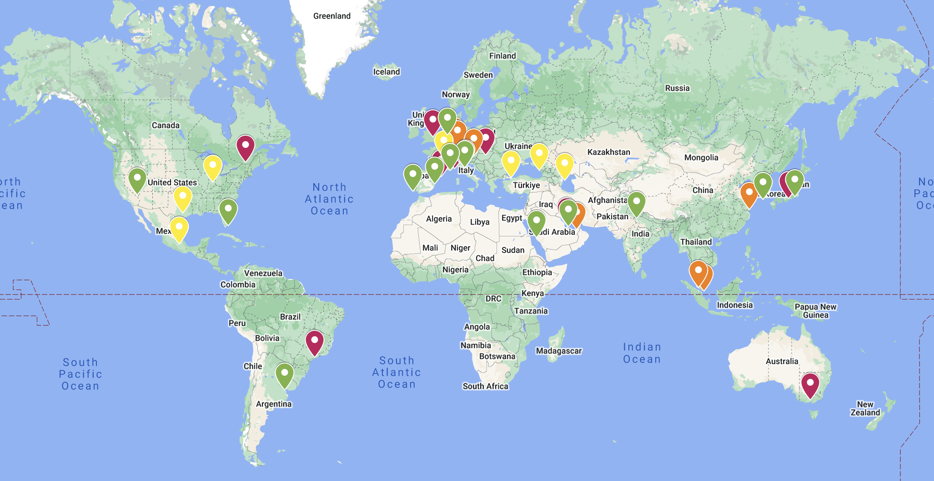
Red indicates races occurred 75-100% of the years in the time period, orange indicates 50-75%, yellow indicates 25-50%, and green indicates 0-25%.

Table 1: Points Rewarded 1998-2002

Finishing Position | Points Earned
1st | 10
2nd | 6
3rd | 4
4th | 3
5th | 2
6th | 1
7th-Last | 0

Table 2: Points Rewarded 2003-2010
Finishing Position | Points Earned
1st | 10
2nd | 8
3rd | 6
4th | 5
5th | 4
6th | 3
7th | 2
8th | 1
9th-Last | 0

Table 3: Points Rewarded 2010-Present
Finishing Position | Points Earned
1st | 25
2nd | 18
3rd | 15
4th | 12
5th | 10
6th | 8
7th | 6
8th | 4
9th | 2
10th | 1
11th-Last | 0

Table 4: Formula 1 Teams 1998-2023
Last/Most Current Team Name | Years Active
Alfa Romeo | 2006-2023
AlphaTauri | 2006-2023
Alpine F1 Team | 2002-2023
Arrows | 1998-2002
Aston Martin | 2006-2023
Benetton | 1998-2001
Caterham | 2012-2014
Ferrari | 1998-2023
Haas F1 Team | 2016-2023
HRT | 2010-2012
Jaguar | 2000-2004
Jordan | 1998-2005
Manor Marussia | 2012-2016
McLaren | 1998-2023
Mercedes | 1999-2023
Minardi | 1998-2005
Prost | 1998-2001
Red Bull | 2005-2023

Stewart | 1998-1999
Super Aguri | 2006-2008
Toyota | 2002-2009
Tyrrell | 1998
Williams | 1998-2023

Table 5: Constructor Changes 1998-2023
Team | Years
BAR → Honda → Brawn → Mercedes | 1999-2005 → 2006-2008 → 2009 → 2010-2023
Virgin → Marussia → Manor Marussia | 2010-2011 → 2012-2014 → 2015-2016
BMW Sauber → Sauber → Alfa Romeo | 2006-2009 → 2010-2018 → 2019-2023
Toro Rosso → Alpha Tauri | 2006-2019 → 2020-2023
Renault → Lotus Renault F1 → Renault → Alpine | 2002-2011 → 2012-2015 → 2016-2020 → 2021-2023
MF1 → Spyker → Force India → Racing Point → Aston Martin | 2006 → 2007 → 2008-2018 → 2019-2020 → 2021-2023

Table 6: Active Formula 1 Tracks 1998-2023
Circuit | Active Years
Albert Park Grand Prix Circuit | 1998-2019, 2022-2023
Autodromo Enzo e Dino Ferrari | 1998-2006, 2020-2023
Autódromo Hermanos Rodriguez | 2015-2019, 2021-2023
Autódromo Internacional do Algarve | 2020-2021
Autodromo Internazionale del Mugello | 2020
Autódromo José Carlos Pace | 1998-2019, 2021-2023
Autódromo Juan y Oscar Gélvez | 1998
Autodromo Nazionale di Monza | 1998-2023
Bahrain International Circuit | 2004-2010, 2012-2023
Baku City Circuit | 2016-2019, 2021-2023
Buddh International Circuit | 2011-2023
Circuit de Barcelona-Catalunya | 1998-2023
Circuit de Monaco | 1998-2019, 2021-2023
Circuit de Nevers Magny-Cours | 1998-2008
Circuit de Spa-Francorchamps | 1998-2002, 2004-2005, 2007-2023
Circuit Gilles Villeneuve | 1998-2008, 2010-2019, 2021-2023
Circuit of the Americas | 2012-2019, 2021-2023
Circuit Park Zandvoort | 2021-2023
Circuit Paul Ricard | 2018-2022

Fuji Speedway | 2007-2008
Hockenheimring | 1998-2006, 2008, 2010, 2012, 2014, 2016, 2018-2019
Hungaroring | 1998-2023
Indianapolis Motor Speedway | 2000-2007
Istanbul Park | 2005-2011, 2020-2021
Jeddah Corniche Circuit | 2021-2023
Korean International Circuit | 2010-2013
Las Vegas Street Circuit | 2023
Lusail International Circuit | 2021, 2023
Marina Bay Street Circuit | 2008-2019, 2022-2023
Miami International Autodrome | 2022-2023
Nürburgring | 1998-2007, 2009, 2011, 2013, 2020
Red Bull Ring | 1998-2003, 2014-2023
Sepang International Circuit | 1999-2017
Shanghai International Circuit | 2004-2019
Silverstone Circuit | 1998-2023
Sochi Autodrom | 2014-2021
Suzuka Circuit | 1998-2006, 2010-2019, 2022-2023
Valencia Street Circuit | 2008-2012
Yas Marina Circuit | 2009-2023

Table 7: Constructors’ Championship Winners 1998-2023
Constructor | Years Won
Brawn | 2009
Renault | 2005, 2006
Ferrari | 1999, 2000, 2001, 2002, 2003, 2004, 2007, 2008
Mercedes | 2014, 2015, 2016, 2017, 2018, 2019, 2020, 2021
Red Bull | 2010, 2011, 2012, 2013, 2022, 2023
McLaren | 1998

Formula1.com. Reference Map 1 in the appendix for a world map of F1 race locations from 1998-2023
Competitive Balance: a measure of fairness and level of equality in sports
Additional information about specific team names and years can be found in Table 5 of the appendix.
Territorial Rights: “​​No team in organized baseball may play in the territory of any other team without the latter's consent. Each team, therefore, monopolizes its own territory within organized baseball, and this monopoly right is a marketable commodity.” (Rottenberg 243). Uniform Contract: A contract signed by a player to play for a team in which “the terms of which are specified in detail by organized baseball.” (Rottenberg 244)
Jude, Booth, and Brooks
Jude, Booth, and Brooks p. 425
Different types of competitive balance are defined later in the Methodology section.
Budzinski and Fedderson p.1
Leeds, Michael A., Peter v. Allmen, and Victor A. Matheson. 2022. “Competitive Balance.” In The Economics of Sports, 127-156. New York: Taylor & Francis Group. p. 134-139.
Specific breakdown of points earned is in Tables 1-3 in the appendix.
Additional information regarding points changes is outlined in Tables 1-3 in the appendix.
P9 is the equivalent of 9th place.

